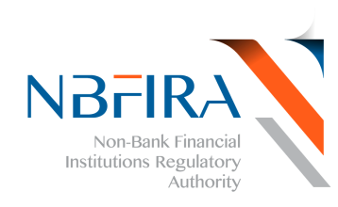OPEN DAY – SELIBE PHIKWE
The Non-Bank Financial Institutions Regulatory Authority (NBFIRA) held an open day on the 15th of August 2014 at in Selibe Phikwe at the Town Park. The event was officiated by SPEDU Acting Coordinator Mr. Pako Kedisitse. Our mandate is to regulate and supervise non-bank financial institutions for the purpose of contributing towards financial stability.
The open day was a culmination of exposing the Selibe Phikwe community to the different functions of the non-bank financial institutions and our consumer education initiative on financial literacy hence our request for your presence and participation during the open day. The event attracted stakeholders who exhibited their products such as CEDA, LEA, MVA, Botswana Stock Exchange (BSE), SPEDU, BHC and the Consumer Protection Department from the Ministry of Trade and Industry.

